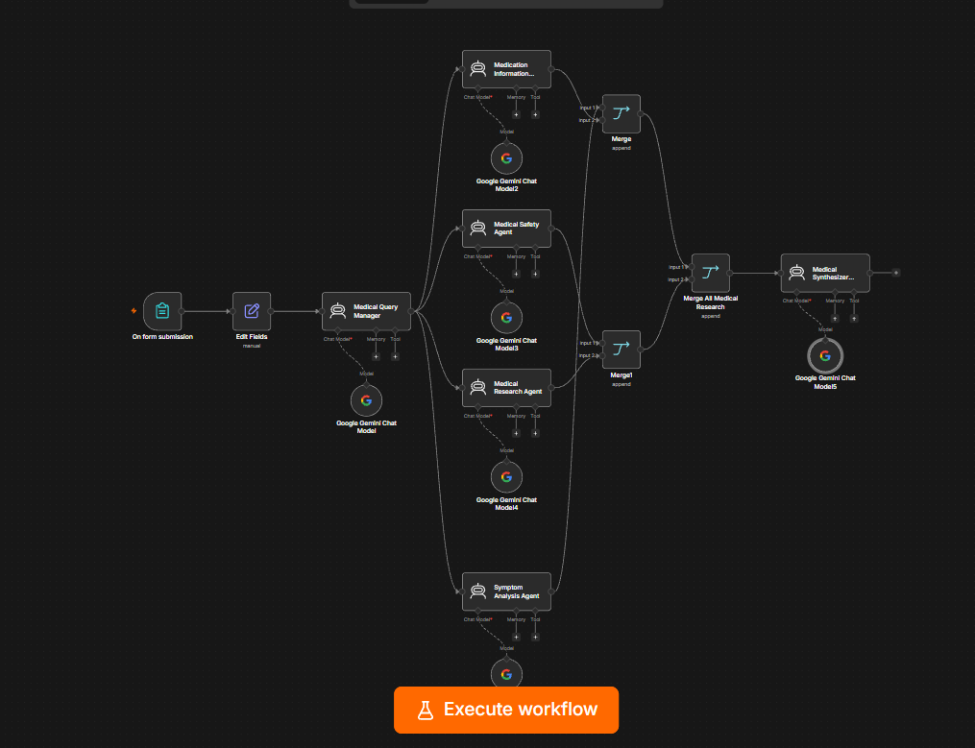
1. Project Title
AI Medical Information Assistant using n8n and Google Gemini

2. Project Level
Level: Hard / Advanced
This project is more advanced than a basic chatbot because it uses multiple specialized AI agents, parallel processing, data merging, safety validation, and a final synthesis stage.
n8n supports AI-agent workflows where LLMs can be combined with tools and other workflow components.

3. Project Objective
The objective is to build an AI-powered medical information assistant that:
- Collects medical information through a form
- Understands the user's medical question
- Separately analyzes symptoms
- Reviews medication-related information
- Performs medical safety and red-flag analysis
- Performs general medical research analysis
- Combines the specialist outputs
- Produces one structured final response
Important: The system is designed for educational medical information, not diagnosis or treatment.

4. Technologies Used
Technology | Purpose
n8n | Workflow automation
AI Agent | Specialized medical reasoning
Google Gemini | LLM for each agent
Form Trigger | Collect patient/user information
Edit Fields | Prepare and organize input
Merge | Combine specialist outputs
Expressions | Pass dynamic data between nodes
n8n's Merge node can combine multiple data streams, including using Append mode to output items from multiple inputs.

5. User Input Form
The form collects:
Field | Example
Name | John
Age | 30
Medical Question | What is migraine?
Symptoms | Headache and sensitivity to light
Duration | 2 days
Existing Conditions | None
Current Medications | None
Allergies | None
Pregnancy Status | Not applicable
Urgency | General Information
Preferred Response | Simple Explanation

6. Workflow Architecture
Your final workflow is structured like this:
On Form Submission
↓
Edit Fields
↓
Medical Query Manager
│
├──────────────→ Symptom Analysis Agent
│ ↓
│ Gemini
│
├──────────────→ Medication Information Agent
│ ↓
│ Gemini
│
├──────────────→ Medical Safety Agent
│ ↓
│ Gemini
│
└──────────────→ Medical Research Agent
↓
Gemini

↓↓↓

Merge Medical Analysis 1
↓
Merge Medical Analysis 2
↓
Merge All Medical Research
↓
Medical Synthesizer
↓
Gemini
↓
Final Response
This parallel specialist-agent structure is what makes the project substantially more advanced than a single AI-agent workflow.

7. Node 1 — On Form Submission
Purpose
Starts the workflow whenever the user submits the medical information form.
Input
The form provides the patient's/user's information.
Output
One structured item containing the submitted fields.

8. Node 2 — Edit Fields
Purpose
The Edit Fields node prepares the form data for the AI agents.
Example:
Name → John
Age → 30
Question → What is migraine?
Symptoms → Headache and sensitivity to light
Duration → 2 days
This makes the information easier to reference using n8n expressions.

9. Node 3 — Medical Query Manager
Purpose
The Medical Query Manager acts as the central coordinator.
It receives the original medical request and passes the relevant information into the specialist branches.
Gemini Connection
Medical Query Manager
↓
Google Gemini Chat Model
Responsibility
The manager should:
- Understand the user's request
- Preserve the user's original information
- Provide context for specialist agents
- Avoid making a diagnosis itself
- Allow specialist agents to perform their individual tasks

10. Node 4 — Symptom Analysis Agent
Purpose
Analyzes the symptoms independently.
Responsibilities
The agent evaluates:
- Reported symptoms
- Duration
- General possible explanations
- Associated symptoms
- General warning signs
- Information that may need professional evaluation
Example
Input:
Symptoms:
Headache and sensitivity to light

Duration:
2 days
Output:
SYMPTOM ANALYSIS

Symptoms identified:
- Headache
- Sensitivity to light

Possible general explanations:
...

Associated symptoms:
...

Warning signs:
...

Information requiring professional evaluation:
...
Safety
The agent must not diagnose the user.

11. Node 5 — Medication Information Agent
Purpose
Analyzes medication-related information.
Responsibilities
It considers:
- Current medications
- Allergies
- Existing conditions
- General medication information relevant to the question
- Potential interaction considerations
- Medication safety considerations
Restrictions
The agent must not:
- Prescribe medication
- Recommend dosage
- Tell the user to stop medication
- Tell the user to start medication
- Invent medications
- Invent allergies

12. Node 6 — Medical Safety Agent
Purpose
This is one of the most important agents.
It independently checks for:
- Red-flag symptoms
- Potentially concerning symptoms
- Risk factors
- Urgency
- Missing safety information
- Situations requiring professional medical evaluation
Example output
SAFETY ASSESSMENT

Potentially Concerning Symptoms:
Persistent headache
Sensitivity to light

Red Flags:
...

Risk Factors:
...

When to Seek Medical Attention:
...

Emergency Considerations:
...

Safety Summary:
...
Your screenshot showed this agent correctly identifying persistent headache and photophobia and beginning a red-flag assessment.

13. Node 7 — Medical Research Agent
Purpose
Provides general medical research/context based on the user's question.
Responsibilities
It analyzes:
- Medical background
- Common symptoms
- General causes/contributing factors
- High-level diagnostic considerations
- General management information
- Safety considerations
- Warning signs
- Evidence limitations
- Questions for a healthcare professional
Important
Because you decided not to use HTTP/PubMed, this agent uses Gemini's available knowledge rather than live external medical literature.
Therefore, it should not claim that it searched PubMed or retrieved live studies.

14. Merge Medical Analysis 1
Purpose
Combines:
Symptom Analysis Agent
+
Medication Information Agent
Configuration
Mode:
Append
Number of Inputs:
2
n8n's Append mode keeps data from all connected inputs and outputs them sequentially.

15. Merge Medical Analysis 2
Combines:
Medical Safety Agent
+
Medical Research Agent
Configuration:
Mode: Append

Number of Inputs: 2

16. Merge All Medical Research
Combines:
Merge Medical Analysis 1
+
Merge Medical Analysis 2
Configuration:
Mode: Append

Number of Inputs: 2
Final result contains the outputs from all four specialist agents.

17. Medical Synthesizer
This is the final AI Agent.
Purpose
The Medical Synthesizer takes the specialist analyses and creates one understandable final response.
Input
Merge All Medical Research
Gemini
Medical Synthesizer
↓
Google Gemini Chat Model

18. Synthesizer Processing
The Synthesizer receives:
Symptom Analysis
+
Medication Analysis
+
Safety Analysis
+
Medical Research
It then:
- Understands the original question
- Reviews all specialist outputs
- Identifies agreement/disagreement
- Prioritizes safety information
- Removes unsupported claims
- Produces one final response

19. Final Response Structure
The final output should contain:
1. Understanding Your Question
Explain what the user asked.
2. General Medical Information
Give educational information.
3. Symptoms and Possible Explanations
Summarize symptoms without diagnosing.
4. Medication Information
Include only when relevant.
5. Safety and Warning Signs
Highlight important warning signs.
6. When to Seek Medical Care
Explain when professional evaluation may be appropriate.
7. Questions for a Healthcare Professional
Provide useful questions.
8. Important Limitations
Explain what the AI cannot determine.
And finish with:
Important: This information is for educational purposes and does not replace advice, diagnosis, or treatment from a qualified healthcare professional.

20. Why This Is Hard Level
Your project contains several advanced concepts:
Feature | Level
Form trigger | Beginner
Data transformation | Beginner
Gemini integration | Intermediate
AI Agent | Intermediate
Multiple AI agents | Advanced
Parallel agent architecture | Advanced
Specialized agents | Advanced
Safety agent | Advanced
Research agent | Advanced
Multiple Merge nodes | Advanced
Final synthesis | Advanced
Prompt engineering | Advanced
Safety constraints | Advanced
Multi-agent orchestration | Hard

21. Skills Demonstrated
If you put this project on your resume, you can demonstrate:
- n8n workflow automation
- Generative AI
- Google Gemini integration
- Multi-agent AI architecture
- Prompt engineering
- AI workflow orchestration
- Data transformation
- Parallel processing
- Data aggregation
- AI safety design
- Structured output generation
- LLM-based information synthesis

22. Project Flow in Simple Words
You can explain the project in an interview like this:
"I built a multi-agent medical information assistant in n8n. A user submits their medical question and relevant information through a form. A central Medical Query Manager distributes the request to four specialized agents: Symptom Analysis, Medication Information, Medical Safety, and Medical Research. Each agent independently analyzes a specific aspect of the request using Google Gemini. Their outputs are then combined through Merge nodes and passed to a final Medical Synthesizer, which generates a structured educational response while applying safety restrictions and avoiding diagnosis or prescription."
That is a strong interview explanation.

23. Current Architecture Status
Based on the workflow you've built:
Project: AI Medical Information Assistant
Difficulty: ⭐⭐⭐⭐⭐ Hard
Architecture: Multi-Agent
LLM: Google Gemini
Specialist Agents: 4
Final Synthesizer: 1
External API: Not currently used
Safety Layer: Yes
Parallel Processing: Yes
Data Merging: Yes
Your use of Merge nodes is consistent with n8n's documented approach for combining multiple data streams.
One important limitation: because you chose not to add an external medical literature API, call the Medical Research Agent an AI medical research/context agent, not a live evidence-retrieval system. If you later add a verified medical source, the project becomes even stronger.

